- The first business surveys of Q3 provided more evidence that the UK economic recovery has now taken root. While it's still early days, our forecast that q/q GDP growth is likely to remain solid in Q3, albeit slightly slower than in Q2, remains on track.
- With market interest rate expectations signalling that next week's monetary policy decision is finely balanced, the silence from those monetary policymakers who are close to voting for a rate cut is striking. We interpret this as a lack of urgency to lower Bank Rate in August and continue to lean towards the first rate cut taking place at September's meeting.
After output fell in H2 2023, the economy has experienced strong gains so far in 2024, signalling that a recovery is firmly afoot. And this week's first business survey for July suggested that the good underlying momentum in the economy carried through to the start of Q3.
July's flash S&P Global PMI survey reported a slightly faster pace of private sector activity growth than in June, with the composite PMI rising to 52.7 from 52.3 last month. The uptick was driven by stronger growth in output, new orders, and employment, across both the services and manufacturing sectors, with survey respondents citing improved confidence after some firms put plans on hold in the run-up to the election.
Over the past couple of years, the S&P Global survey has had an adequate track record as a leading indicator of official output for the sectors it covers. However, the relationship with GDP has often been weaker because of volatility in the retail and public sectors, neither of which are covered by the survey (Chart 1). But we expect this link to strengthen, with fewer days lost to public sector strikes in July than in recent months, a public sector pay deal looming, and the likelihood that the exceptional volatility in retail sales volumes over the past six months dies down. As a result, another composite PMI reading well above the 50 'no-change' and better outturns in the survey's forward-looking balances raises our confidence that the economic recovery continued into Q3, albeit with slower momentum than in Q2.
Chart 1: July's S&P Global PMI survey suggested the recovery is likely to persist into Q3
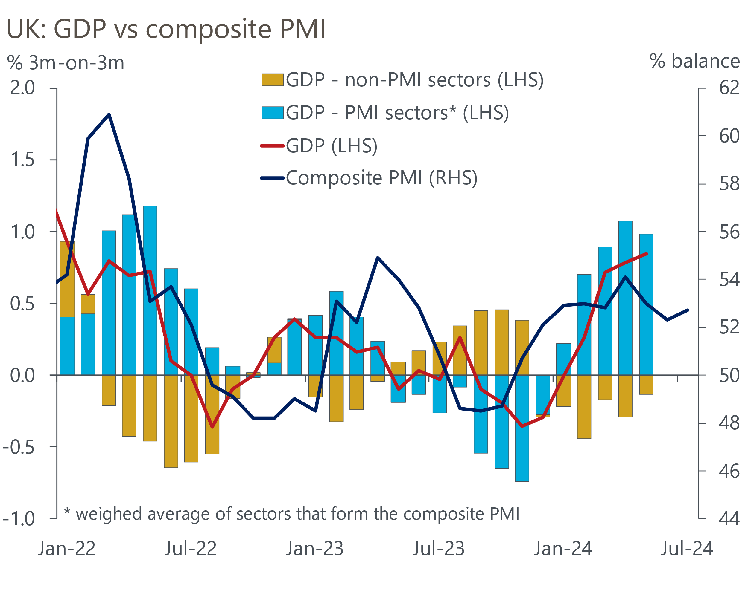
Sources: Oxford Economics, ONS, S&P Global

Despite signs of stronger output growth, the S&P Global survey also pointed to a cooling in inflationary pressures. Input cost inflation fell modestly as though the impact of ongoing disruption to shipping in the Red Sea raised the cost burden for manufacturers, this was more than offset by softer wage settlements in the services sector. The divergence in sectoral fortunes was present in output prices too, with the slowdown in prices charged inflation in July entirely driven by the services sector.
While the Bank of England's Monetary Policy Committee has long focused on services inflation as a key indicator of inflation persistence, the week's survey evidence of moderating price and cost pressures in the sector will have few implications ahead of August's interest rate decision. Instead, the focus remains on how the MPC's more dovish members have interpreted last week's upside surprise for official services inflation and the subsequent market reaction to price in a lower probability of a rate cut.
Though June's outturn for services inflation came in 0.6ppts above the latest BoE staff projections, we doubt that the group of committee members who signalled their June decision was "finely balanced" will be particularly concerned. Indeed, June's services inflation forecast overshoot can be traced back to the combination of April's larger-than-expected uprating of index-linked contracts and exceptionally large m/m price hikes by two hotels between May and June. With the former reflecting past inflation and the latter a temporary quirk, neither should have consequences at the time horizon relevant for monetary policy.
Nevertheless, prior to June's inflation release, market pricing was in favour of a 25bps rate cut at the August MPC meeting. Yet at the time of writing, the implied probability of an August cut has fallen to slightly under 50% (Chart 2). None of the committee members who appear close to voting for a rate cut (namely Bailey, Breeden, and Lombardelli) have provided any on-the-record comments since last week's market repricing. And given the MPC hasn't gone against the market consensus since November 2021, we interpret their silence as a lack of urgency to loosen policy in August. While the decision is a very close call, we expect the committee will vote to keep Bank Rate unchanged again in August and use the subsequent Monetary Policy Report and press conference to signal that the first rate cut will come in the September meeting.
Chart 2: Market participants have raised their interest rate expectations in recent weeks
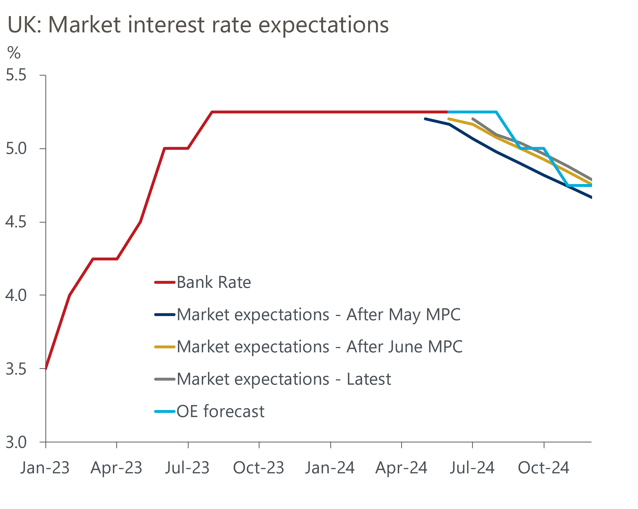
Sources: Oxford Economics, Haver Analytics
As the MPC considers the timing and pace of future rate cuts, the tightness of fiscal policy going forward remains a key uncertainty. On this front, Chancellor Rachel Reeves announced that she will present an assessment of the UK's public finances to Parliament on Monday, alongside the government's response to recent public sector pay recommendations. As we laid out in a Research Briefing published earlier this week, we think the Chancellor's review will conclude that the Labour government's fiscal inheritance is worse than was feared, paving the way to additional tax hikes beyond those in its manifesto, alongside a less aggressive public spending squeeze. In this case, we would not expect the government to breach its manifesto commitments to keep the main taxes on incomes, spending and profits unchanged, with any further tax increases likely to be focused on other measures such as capital gains and inheritance tax. To us, such a shift would deliver a more credible route to meet the fiscal rules than the existing fiscal plans.

The week ahead
August's MPC meeting will be the centre of attention next week. With the MPC's long-running focus on services inflation as an indicator of inflation persistence, June's outturn coming in 0.6ppts higher than the latest BoE staff forecast led market participants to scale back their bets of a 25bps rate cut in August. That June's overshoot for services inflation can be traced back to April's larger-than-expected uprating of index-linked contracts and very large m/m price rises in two individual hotels, suggests the recent data shouldn't unnerve the committee doves. But given none of those who we think are close to voting for a rate cut have opted to provide any on-the-record comments to get markets onside for an August cut, we expect the committee will vote to keep Bank Rate at 5.25% and use the Monetary Policy Report and press conference to lay the groundwork for a 25bps cut at the September meeting.
As discussed above, Chancellor Rachel Reeves will deliver an audit of the public finances to Parliament on July 26. We expect it to highlight that the UK's current fiscal position is fragile and not on a sustainable path. Particular focus is likely to be on the reported near-£20bn funding shortfall for public services and the government's plans to rectify this via additional tax hikes beyond those in its manifesto. With Parliament's summer recess due to begin on July 30th, there is also speculation that the Chancellor will announce the date of her Autumn Budget next week.
June's BoE data on lending to households is likely to show that mortgage demand remained broadly stable. Quoted interest rates on average two- and five-year fixed rate 75% LTV mortgages only shifted down by a few basis points each during the month, so we forecast mortgage approvals held steady at the 60,000 mark in June. Meanwhile, owing to the time lag between a mortgage being approved and funds being dispensed, the recovery in mortgage demand in Q1 2024 is likely to have supported stronger net mortgage lending in June. Some normalisation in mortgage repayments, following May's very sharp increase, should also have acted as a source of upward pressure. Therefore, we expect net secured lending to have risen to £2.7bn in June.
Consistent with a large rebound in retail sales volumes in May, net unsecured lending rose to £1.5bn, from £0.8bn in April. So, following another increase in retail sales in June and higher consumer confidence, this suggests households may have adopted a slightly less cautious attitude towards taking on credit at the end of Q2. As a result, we think net unsecured lending ticked up to £1.7bn in June.
July's flash manufacturing PMI rose to a two-year high of 51.8 following reports of stronger production and an improving pipeline of new orders. With no clear pattern to revisions, we expect the final results to come in close to this week's flash survey.
Table 1: Week ahead calendar
Date | Events | Period | Measure | Unit | Previous | Forecast
Jul 29 | Mortgage approvals | Jun | Level | 000s | 60.0 | 60.0
Jul 29 | Mortgage lending | Jun | Net lending | £bn | 1.2 | 2.7
Jul 29 | Consumer credit | Jun | Net lending | £bn | 1.5 | 1.7
Aug 1 | Nationwide house prices | Jul | m/m | % | 0.2 | 0.3
Aug 1 | Nationwide house prices | Jul | y/y | % | 1.5 | 2.0
Aug 1 | S&P Global/CIPS manufacturing | Jul | PMI | % bal | 51.8 | 51.8
Aug 1 | BoE Bank Rate decision | Aug | Bank Rate | % | 5.25 | 5.25
Source: Oxford Economics

Key forecasts
Table 2: UK forecast overview
(Annual percentage changes unless specified)
 | 2022 | 2023 | 2024 | 2025 | 2026 | 2027
GDP | 4.3 | 0.1 | 1.1 | 2.0 | 1.9 | 1.7
Private consumption | 4.8 | 0.2 | 0.8 | 2.4 | 2.2 | 1.6
Fixed investment | 8.0 | 2.2 | -0.1 | 1.3 | 2.7 | 2.1
Government consumption | 2.3 | 0.5 | 2.9 | 3.2 | 1.6 | 1.5
Exports of goods and services | 9.0 | -0.5 | -2.3 | 2.6 | 2.3 | 1.7
Imports of goods and services | 14.6 | -1.5 | -0.4 | 3.7 | 2.9 | 1.9
Industrial Production | -3.5 | -0.4 | -0.3 | 0.8 | 1.5 | 1.2
Consumer prices | 9.1 | 7.3 | 2.6 | 2.5 | 2.3 | 2.2
Unemployment rate (%) | 3.9 | 4.0 | 4.4 | 4.2 | 3.9 | 3.9
Current a/c balance (% of GDP) | -3.1 | -3.3 | -3.4 | -3.2 | -3.3 | -3.2
Government balance (% of GDP) | 4.4 | 5.0 | 3.7 | 3.2 | 2.3 | 1.5
Cen. bank policy rate (%, EOP) | 3.50 | 5.25 | 4.75 | 3.75 | 2.75 | 2.00
10yr govt. bond yield (%, EOP) | 3.67 | 3.54 | 4.00 | 3.67 | 3.19 | 2.85
Exchange rate (US$ per £, EOP) | 1.20 | 1.27 | 1.26 | 1.28 | 1.30 | 1.32
Exchange rate (euro per £, EOP) | 1.13 | 1.15 | 1.18 | 1.18 | 1.17 | 1.16
Source: Oxford Economics
Table 3: Quarterly forecasts for the UK
 | 2024 |  |  |  | 2025
 | Q1 | Q2 | Q3 | Q4 | Q1 | Q2 | Q3 | Q4
GDP (% year) | 0.3 | 0.8 | 1.2 | 2.1 | 1.9 | 1.9 | 2.1 | 2.2
CPI inflation (% year) | 3.5 | 2.1 | 2.1 | 2.6 | 2.5 | 2.4 | 2.6 | 2.4
Bank Rate (%, EOP) | 5.25 | 5.25 | 5.00 | 4.75 | 4.50 | 4.25 | 4.00 | 3.75
10yr gilt yield (%, EOP) | 3.95 | 4.17 | 4.05 | 4.00 | 3.92 | 3.85 | 3.76 | 3.67
US$ per £ (EOP) | 1.26 | 1.26 | 1.26 | 1.26 | 1.26 | 1.27 | 1.27 | 1.28
Euro per £ (EOP) | 1.17 | 1.18 | 1.18 | 1.18 | 1.18 | 1.18 | 1.18 | 1.18
Source: Oxford Economics

Latest Country Economic Forecast:
July 16, 2024

Recent publications

Data Insights
Flash PMIs suggest the economy got off to a solid start in Q3
Noisy retail data masks gradual underlying improvement
Borrowing overshoot likely to continue through 2024-2025
Mixed messages from labour market data add to MPC's dilemma
Services inflation continues to surprise to the upside

Research Briefings
MPC preview – Markets hold the key to timing of rate cut
Labour's fiscal inheritance and the Reeves Review
MPC prepares the ground for an August rate cut
Why Labour and Tory manifestos are a missed opportunity
MPC preview – The clues will be in the language

Contacts

Oxford Economics' UK team
- Andrew Goodwin - Chief UK Economist - agoodwin@oxfordeconomics.com
- Edward Allenby - UK Economist - eallenby@oxfordeconomics.com

